2019

1.Our mechanical and Electrical students participated in SAE –Ebaja 2019 at Pithampur ,Indore, Madhya pradesh and won 4th place all over India and 1st place in tamilnadu in the static event. On january 2019.

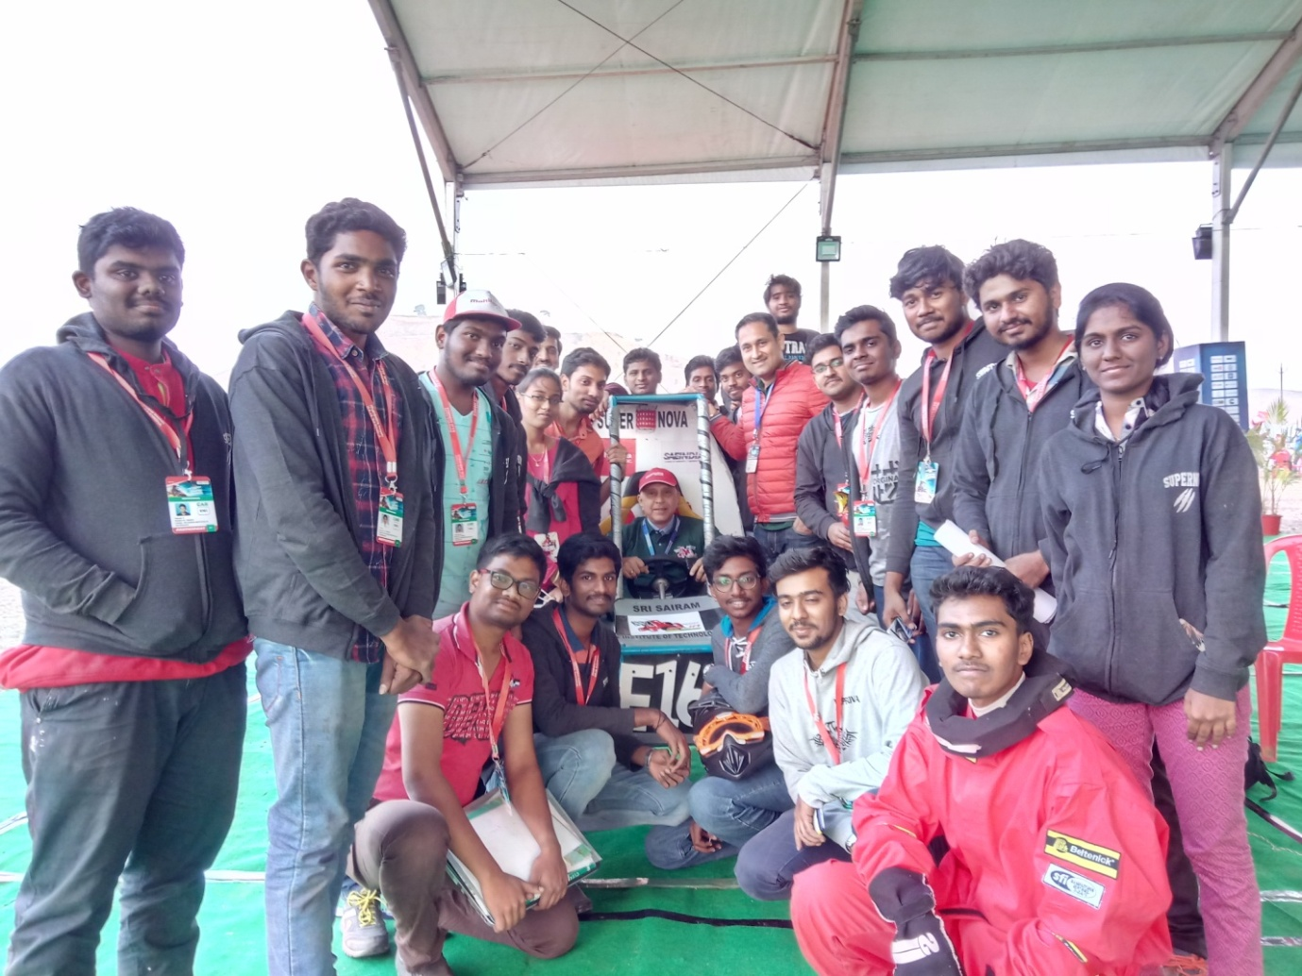

2.Sathyanarayanan and Sivaramakrishnan students of III year and IV year has won Second Prize in two event in National level technical symposium conducted by PSG Tech ,Coimbatore on 17.03.2019.

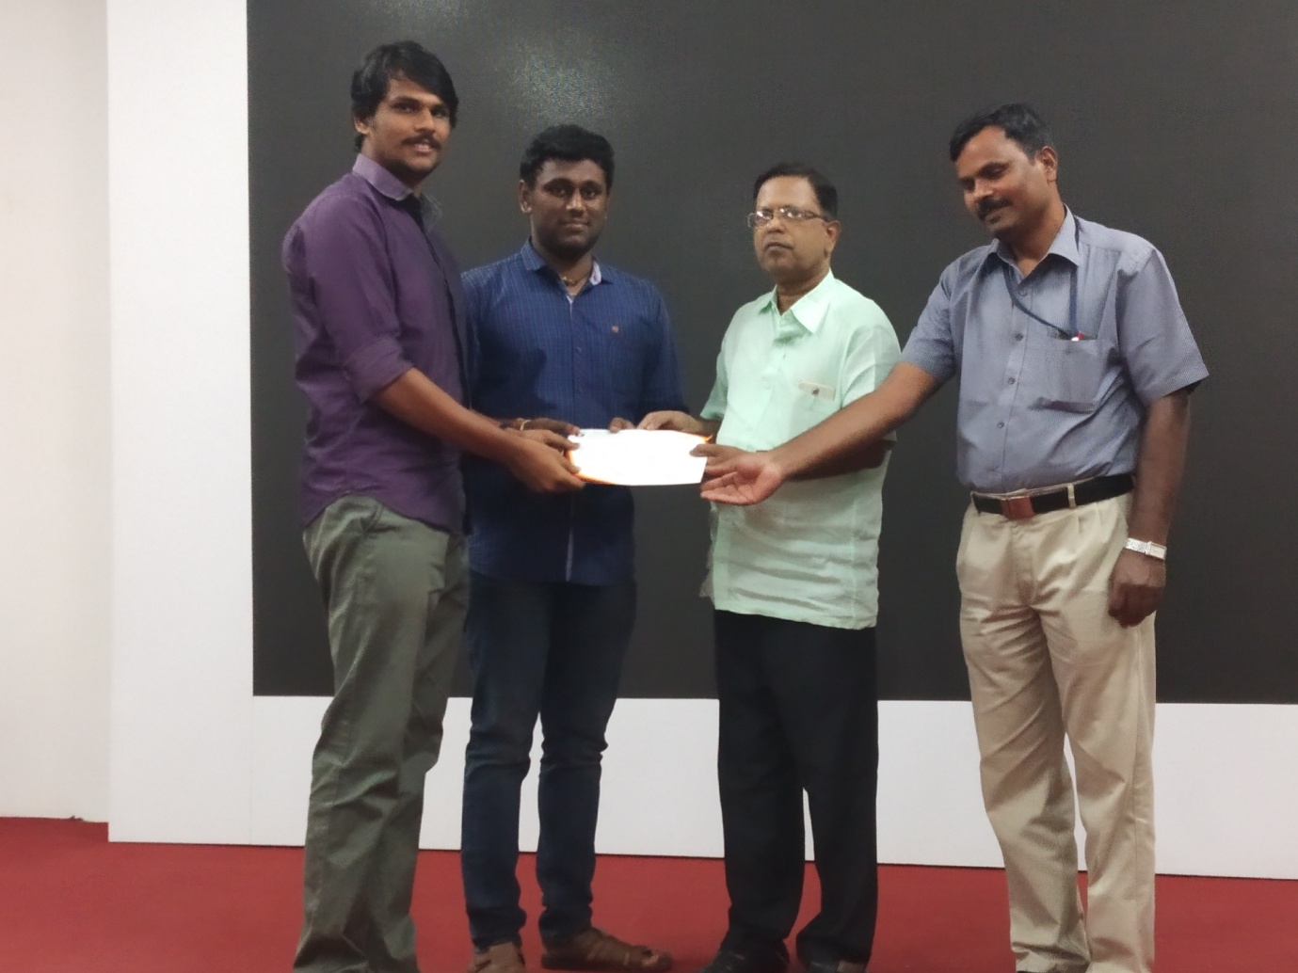

1. K.Gowthamkumar, IV year Selected as the Best Student by Institute of Engineers India for the academic year 2018-2019.
2. 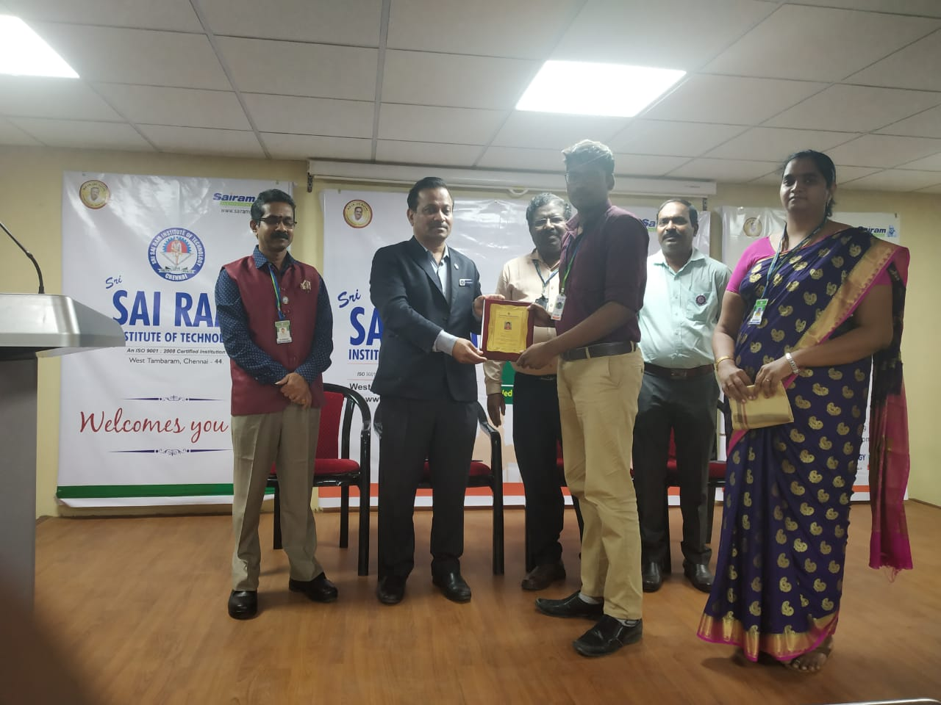

2018

1. Prakash raj,Jai Krishna, Shabin, and Sanjay from mechanical engineering department won the first prize with cash of Rs.15000 from National Level Startup Program by AICTE at LJ Group of Institutions.

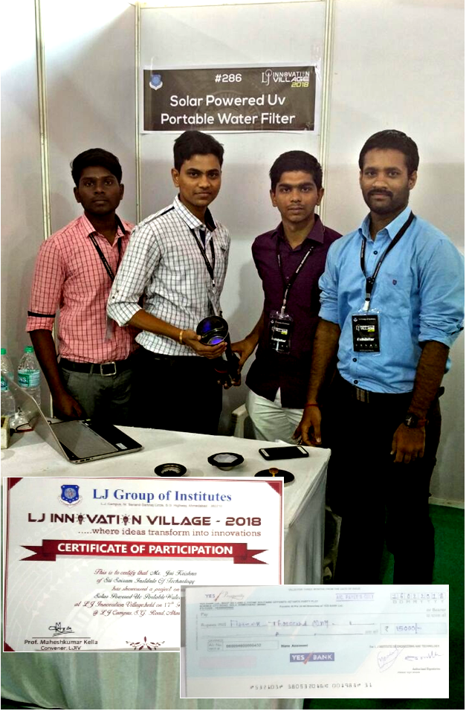

2.L.Nikitha, IV year Selected as the Best Student for “Innovation , Technology and Knowledge Economy” for the academic year 2017-2018.

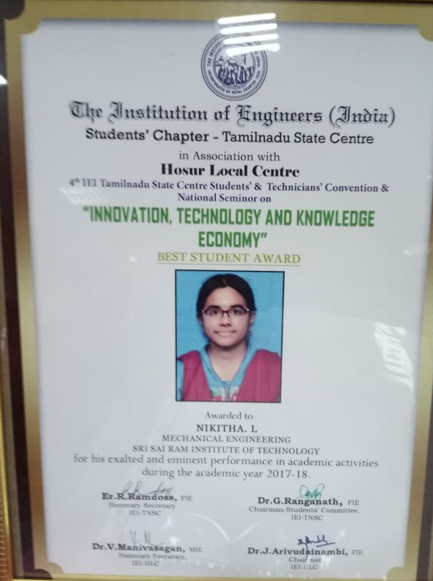

Our students  B.Rudhramoorthi (IV - year) , M.Hemkumar (IV - year) of mechanical department Won 2nd Prize  in All over India in the “Students Engineering Model Competition” , India International Science Festival,at Lucknow on November 2018.

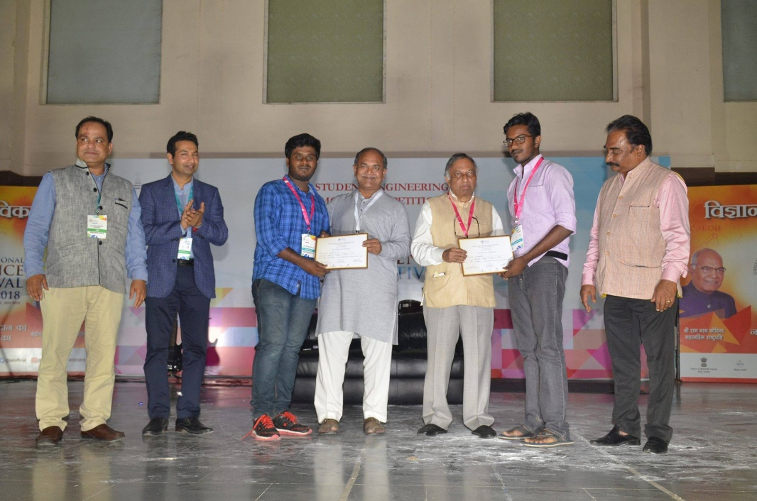

2017

1. “ SUPER NOVA “ E-Baja Team from Mechanical and Electrical Engineering Department team won **1Laksh** Rupees in **SAE E- Baja 2017.**

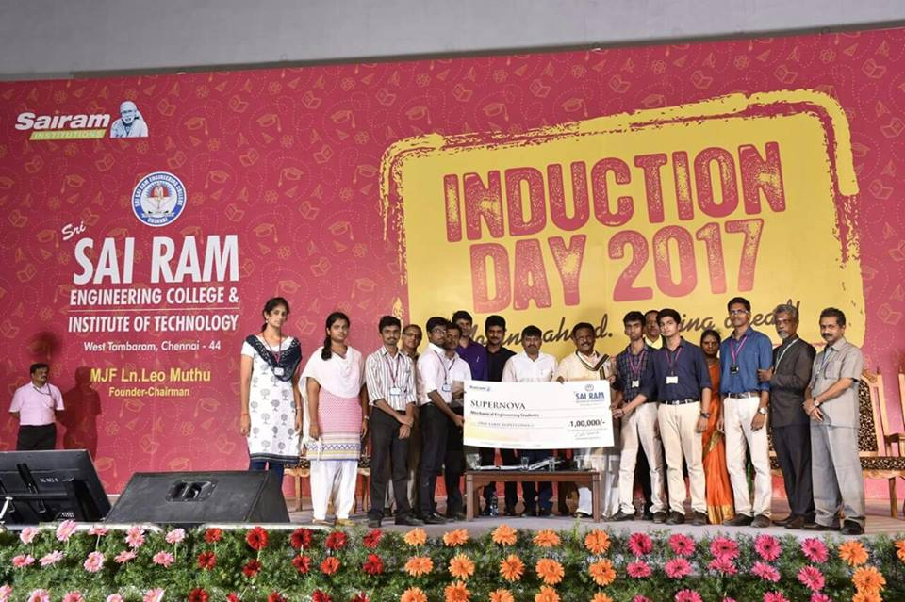

2. Saranyan Sankrith S, Sathya Narayanan S, Siva Subramanyam K.P from Mechanical Engineering Department won the third prize with cash award of Rs.10000 in **INDIA DESIGN SUBMIT 2017 National Level Design Contest at Sai Ram Engg College**

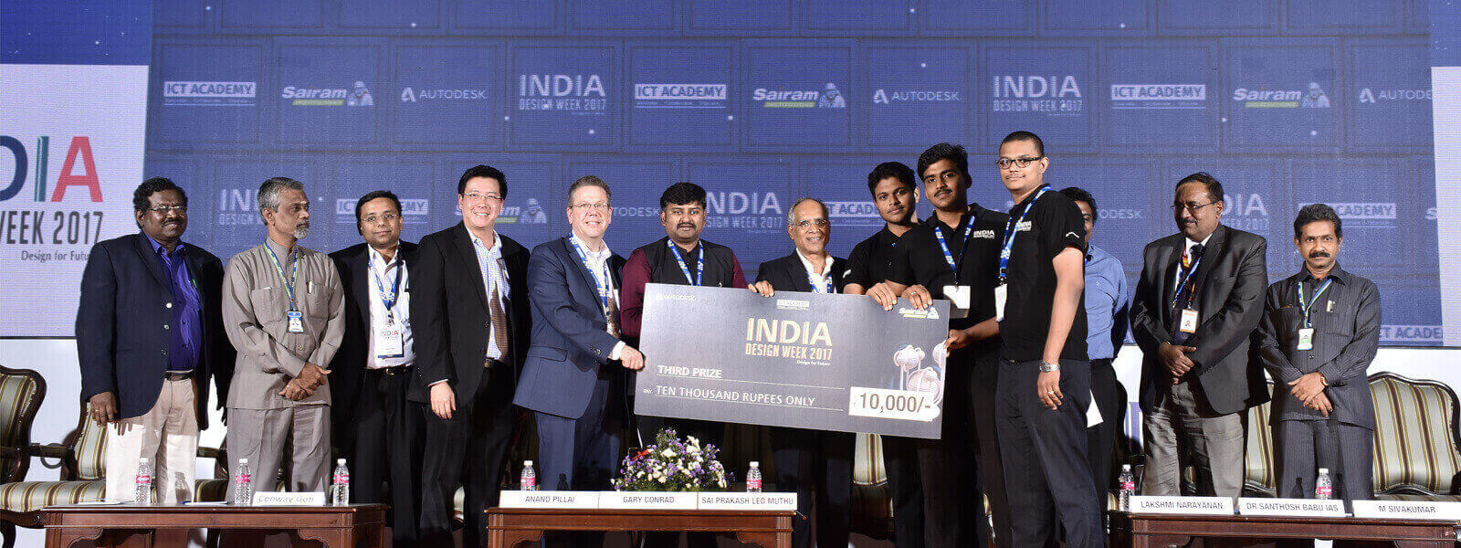

1. K.R.Bharat , IV Mechanical Student won the “ Best Student Award 2017 “ by ISTE on 4.3.2017

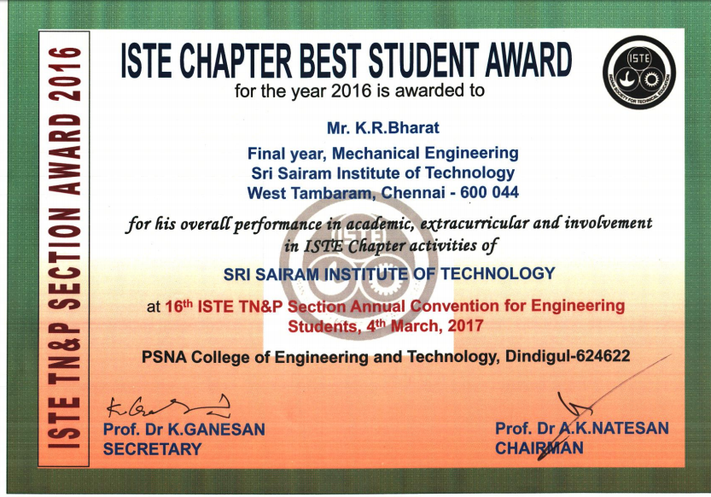

The Department has been awarded “Responsible And Innovation Award 2017” by Society for Educational and Entrepreneurship Development (SEED )

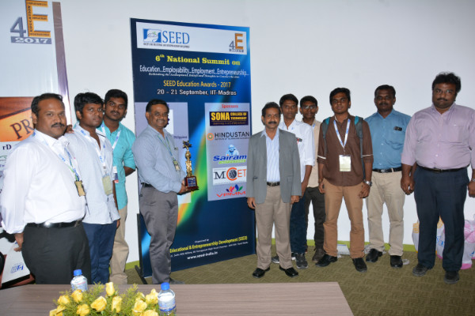

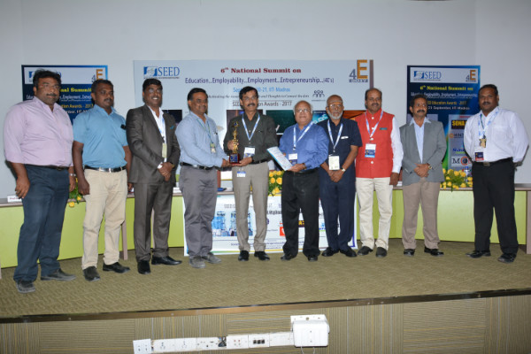

2016

1. K. Abishek of Final year student received the best paper presentation award in FAME 2016 at Sathyabama University on 07.07.2016 to 09.07.2016.

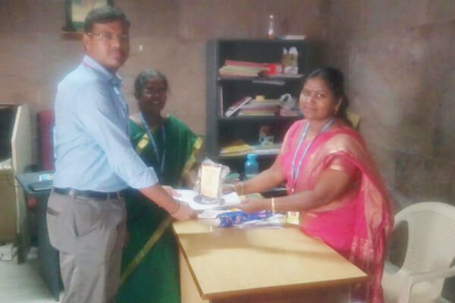

1. **Edvin V Jerry,** Final Year Mechanical Engineering Student received **“ISTE Best Student 2015.**
2. 